# **Exploring Video Game Lighting Techniques: Performance and Visual Quality Trade-offs**

## **Introduction**

Lighting is a critical aspect of creating immersive and visually appealing video game environments, setting the mood, guiding player attention, and enhancing the overall aesthetic of virtual worlds (El-Nasr et al, 2005). However, achieving high-quality lighting in video games is a complex task that requires careful consideration of performance, artistic style, technical constraints, and target hardware (Akenine-Möller et al, 2018). Game developers must strike a balance between visual fidelity and computational efficiency, employing optimization techniques such as pre-computed lighting (Akenine-Möller et al, 2018), light probes (Lambru et al, 2021), level-of-detail (LOD) techniques (Iones et al., 2019), hardware acceleration, and the utilization of graphics APIs like DirectX and Vulkan (Wang, 2020) to reduce computational overhead while maintaining acceptable visual quality.

This research paper will explore various lighting techniques used in video games, including static lighting (pre-computed, non-dynamic lighting), dynamic lighting (real-time lighting that updates with changes in the environment), global illumination, and physically based rendering (a lighting model that simulates light behavior based on real-world physical properties). It will examine their implementations, performance considerations, and suitability for different game types and platforms. The paper argues that balancing performance and visual quality in video game lighting is a dynamic equilibrium that varies based on factors such as artistic style, technical constraints, targeted hardware, and intended gaming experience (El-Nasr et al, 2005). By analyzing the trade-offs between performance and visual quality, this paper aims to provide insights into achieving the desired balance that enhances the overall gaming experience without compromising performance.

## **Static Lighting**

Static lighting refers to pre-computed, non-dynamic lighting techniques used in video games. These techniques involve calculating lighting information offline and storing it in textures or light maps, which are then applied to the game's environment during runtime (El-Nasr et al, 2005). It offers more realistic and consistent lighting effects due to pre-computed calculations, but it lacks the dynamism and responsiveness of dynamic lighting techniques. In fast-paced games, baked in lighting offers improved performance thus being preferred for e-sports titles such as (Counter Strike, Valorant, Rainbow Six and more…). (Wang, 2020)

## **Dynamic Lighting and Real-Time Effects**

Dynamic lighting refers to real-time lighting techniques in video games that update as the game environment changes. These techniques calculate lighting information on the fly, considering factors such as the position and movement of light sources, the geometry of objects in the scene, and the materials properties of those objects. Dynamic lighting can simulate the effects of moving sources of light, changing weather conditions, and time of day, adding a level of realism that static lighting cannot match. Thus, it creates a more engaging and interactive experience for the players. Often dynamic lighting can be observed as shadows for characters are generated.

## **Global Illumination**

Global illumination refers to the simulation of indirect lighting in a virtual environment. Indirect lighting includes the bounce and scattering of light, which contributes to realistic lighting effects such as soft shadows, color bleeding, and ambient occlusion. Global illumination techniques aim to capture these complex interactions of light to achieve more realistic and natural lighting in video games. Global illumination techniques can be computationally expensive and can impact game performance, especially in real-time applications.

## **Physically Based Rendering in Game Design**

In the past, video game creators used multiple textures and maps for each object part to simulate different lighting conditions. Now, they create a single texture per part and use a physics model to control light and shadows in the game. This physics model computes how light from a source will:

1. Reflect and refract off a given surface with varying angle, reflectivity, absorption, and diffusion characteristics.
2. Reduce in intensity and change wavelength as it interacts with surfaces.

By using this method, game developers can create more realistic and dynamic lighting that changes naturally as the game environment and lighting conditions change (El-Nasr et al, 2005). This means they don't have to make a new texture for every possible situation, saving time and effort while still making the game look better. Using a single texture can be problematic due to its high memory demand (Doghramachi, 2020). This is because you can't load and unload multiple texture files as needed, resulting in a larger file size that may not fit within the memory constraints of older hardware (Doghramachi, 2020). One challenge is the computational complexity of physically based rendering, which can strain hardware resources and impact performance (El-Nasr et al, 2005).

## **Performance Considerations for Game Lighting**

While techniques such as Global Illumination and Dynamic Lighting produce a highly realistic gaming experience, they require a significant number of computational resources. (Arvidsson et al, 2020) To balance the visual quality of these advanced lighting techniques with the performance requirements of real-time rendering, game developers often employ various optimizations and approximations.

The impact on game performance must be carefully considered when implementing advanced lighting (Arvidsson et al, 2020). A common technique we notice is using a combination of lighting techniques such as a mix of real-time lighting and pre-computed lighting. For example, the game "The Last of Us" (shown below) utilizes a combination of dynamic lighting for real-time interactions and pre-computed lighting for more static elements of the environment.

Figure 1:

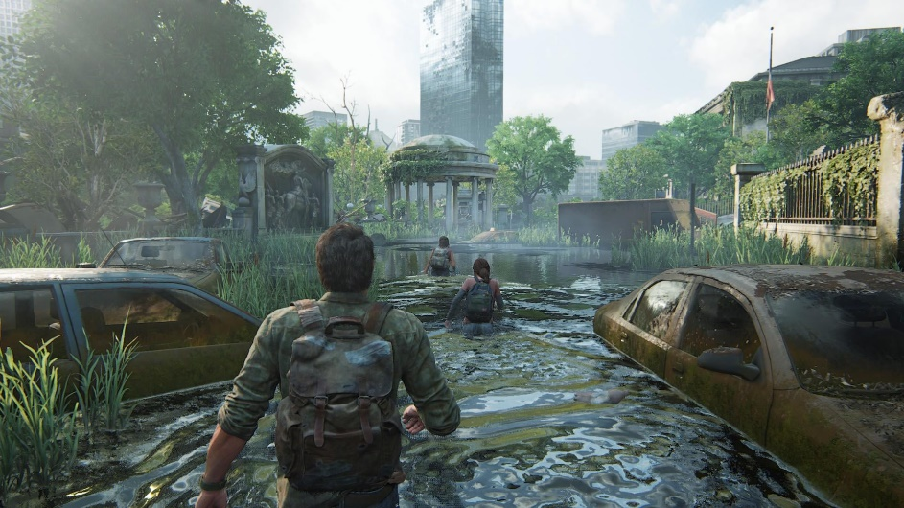

(TheBerkay, 2023)

Notice how there are no character model shadows being generated. The game uses the large water body to create an effect like a dynamically lit shadow, instead of generating character model shadows. This hybrid lighting approach optimizes gameplay by avoiding computationally intensive character shadows.

Figure 2:

(MKIceAndFire, 2023)

The image shows lighting reacting to character models and the environment. Static elements like the sun shining on the backboard use pre-baked or static lighting, while reflections on character models and faces are dynamic, rendering based on their direction relative to the sun and other objects.

## **Lighting Techniques for Different Game Genres**

The choice of lighting techniques in a game must align with the game's genre and artistic style. Different game genres require distinct lighting approaches to support their unique visual styles and atmospheres. For example, a realistic military shooter may benefit from physically based rendering and global illumination, while a stylized platformer might opt for more simplified, cartoon-like lighting.

Horror games often employ low-light environments, dynamic shadows, and flickering light sources to create suspense and unease. In contrast, adventure games may use bright, vibrant lighting to highlight the game's exploration and discovery aspects. The intelligent use of lighting can significantly enhance the game's mood and player immersion. (Cheng et al, 2023)

Figure 3:

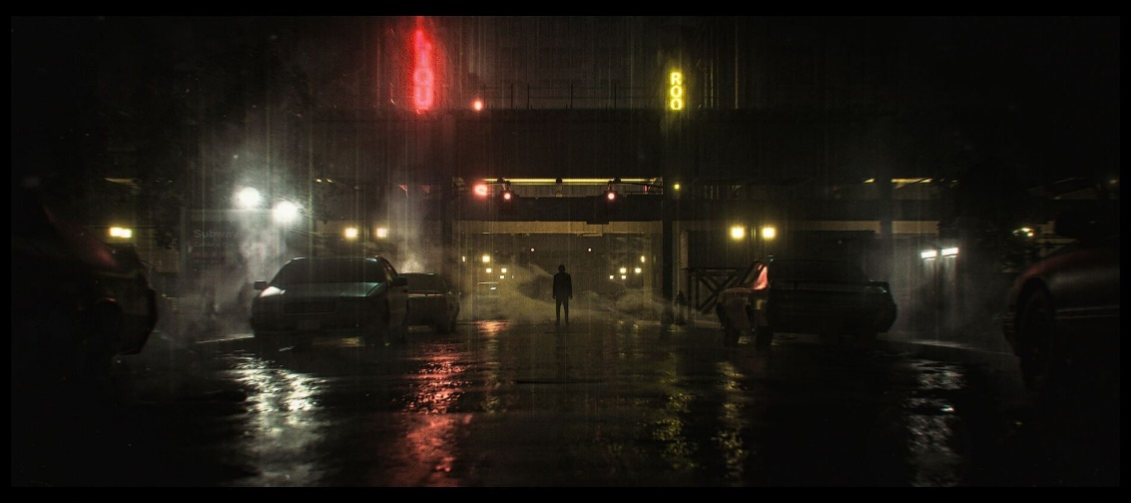

(Skrebels, 2023)

The image above is from the game Alan Wake 2, a horror survival game where the developers at Remedy Entertainment employed artistic techniques such as low lighting, and more to get dystopic feeling.

## **Adapting Lighting Strategies for Various Platforms**

The target hardware and intended gaming experience also influence the selection of lighting techniques. Console games, PC games, and mobile games each present unique challenges and opportunities.

For instance, mobile games may need to rely more heavily on baked lighting and simpler shading models due to the limited processing power of mobile devices. PC games, on the other hand, can take advantage of the latest graphics APIs and powerful GPUs to deliver cutting-edge lighting effects.

Figure 4:



(Moore, 2019)

The image from PUBG Mobile shows significantly lower texture quality and no dynamic lighting. All lighting is pre-baked onto low-resolution maps to optimize performance.

Console games often fall somewhere in between, with developers having to balance the desire for high-quality visuals with the need to maintain a stable framerate on fixed hardware specifications. Therefore, the choice of lighting techniques should be carefully considered based on the capabilities and limitations of the target platform. (Arvidsson et al, 2020)

Trade-offs Between Performance and Visual Quality

Achieving high-quality lighting effects while maintaining optimal performance is a key challenge in video game development. Advanced lighting techniques like global illumination and dynamic shadows enhance realism but are computationally expensive, especially on resource-constrained platforms. (Arvidsson et al, 2020)

Optimization strategies can help reduce computational overhead. Pre-computed lighting, light probes, and level-of-detail (LOD) techniques are some common techniques used alongside hardware acceleration software such as DirectX and Vulkan. However, these optimizations and trade-offs must be carefully evaluated to ensure they don't significantly compromise the visual quality or the game's intended atmosphere and style. As seen in Figures 1,2 and 3 the trade-offs have been made in such a way that they are negligible or not noticeable for the player.

Enhancing Gaming Experience Through Optimal Lighting Balance

Balancing the performance and visual quality of lighting techniques is critical to enhancing the overall gaming experience. At the same time, maintaining a smooth and responsive gameplay experience is crucial for player engagement and satisfaction.

Intelligent lighting systems can play a significant role in this balance. By dynamically adjusting lighting based on game state, player actions, or scripted events, intelligent lighting can guide player attention, convey mood and atmosphere, and even influence gameplay (Cheng et al, 2023).

Conclusion

To conclude, achieving the optimal balance between performance and visual quality in video game lighting is a complex and dynamic process. There is no one sure-shot method or combination of lighting systems that can be used for all games to achieve the optimal experience for players. It requires careful consideration of various factors, including the game's genre, artistic style, and target platform, as well as the ongoing advancements in game development technology and hardware capabilities.

**Works Cited**

Tomas Akenine-Möller, Eric Haines, Naty Hoffman, Angelo Pesce, Michał Iwanicki, and Sébastien Hillaire. _Real-Time Rendering_. Boca Raton, Crc Press, Taylor & Francis Group, 2018.

Arvidsson, Natali, and Ana Laura Martínez. "Balance between Performance and Visual Quality in 3D Game Assets Appropriateness of Assets for Games and Real-Time Rendering Faculty of Arts Department of Game Design." Diva Portal, 2020, [www.diva-portal.org/smash/get/diva2:1444282/FULLTEXT01.pdf](http://www.diva-portal.org/smash/get/diva2:1444282/FULLTEXT01.pdf)

Cheng, Xiang, et al. "A Review of the Effect of the Light Environment of the VDT Workspace on the 'Learning to Learn' Effect of Video Game Training." Frontiers in Neuroscience, vol. 17, 24 Feb. 2023, p. 1093602, [www.ncbi.nlm.nih.gov/pmc/articles/PMC9998512/](http://www.ncbi.nlm.nih.gov/pmc/articles/PMC9998512/), 10.3389/fnins.2023.1093602

El-Nasr, Magy, and Ian Horswill. “Intelligent Lighting for Game Environments.” _Journal of Game Development_, vol. 1, Jan. 2005, pp. 17–50. <https://www.researchgate.net/publication/229139093_Intelligent_Lighting_for_Game_Environments>

Andrey Iones, Anton Krupkin, Mateu Sbert, Sergey Zhukov. “CSDL | IEEE Computer Society.” _Www.computer.org_, [www.computer.org/csdl/magazine/cg/2003/03/mcg2003030054/13rRUwwslvK. Accessed 6 Mar. 2024](http://www.computer.org/csdl/magazine/cg/2003/03/mcg2003030054/13rRUwwslvK.%20Accessed%206%20Mar.%202024).

Wang, Brandon. “VALORANT Shaders and Gameplay Clarity.” _Technology.riotgames.com_, Riot Games, 30 June 2020, <technology.riotgames.com/news/valorant-shaders-and-gameplay-clarity>.

Cristian Lambru, Anca Morar, Florica Moldoveanu, Victor Asavei, Alin Moldoveanu. “Comparative Analysis of Real-Time Global Illumination Techniques in Current Game Engines | IEEE Journals & Magazine | IEEE Xplore.” _Ieeexplore.ieee.org_, ieeexplore.ieee.org/document/9527241. 01 Sept 2021.

Cheng, Xiang et al. “A review of the effect of the light environment of the VDT workspace on the "learning to learn" effect of video game training.” Frontiers in neuroscience vol. 17 1093602. 24 Feb. 2023, doi:10.3389/fnins.2023.1093602 <https://www.ncbi.nlm.nih.gov/pmc/articles/PMC9998512/>

Editor-in-Chief, Joe Skrebels, Xbox Wire. “Alan Wake 2: The Dark Place Is an Entirely New Experiment for Remedy.” Xbox Wire, 26 Oct. 2023, <news.xbox.com/en-us/2023/10/26/alan-wake-2-dark-place-preview>. Accessed 30 Mar. 2024.MKIceAndFire. “THE LAST of US PART 1 Gameplay Walkthrough FULL GAME [4K 60FPS PS5] - No Commentary.” YouTube, 15 Jan. 2023, <www.youtube.com/watch?v=y99DqGw-jG4>. Accessed 25 June 2023.Moore, Sam. “PUBG Mobile Review — Does It Live up to the Original’s Legacy?” Android Authority, 1 Feb. 2019, <www.androidauthority.com/pubg-mobile-review-853582>. TheBerkay. “My First Playthrough. The Last of Us Part I on PC Is Simply Breathtaking. Visuals, Animations, Gameplay... Everything Is Top-Notch.” Reddit, 30 Dec. 2023, <www.reddit.com/r/gaming/comments/18uncj6/>